SYSTEMS & SCALE
MIDDLE SCHOOL

STUDENT PAGES
(Reading)



Environmental Literacy Project

Lindsey Mohan and Hui Jin
With help from Jonathon Schramm, Li Zhan, Valencia Moses, Jim Ratcliffe, Dante Cisterna, and Andy Anderson

Revised October 2009
Activity 5: Energy and Machines

Reading: Forms of Energy

Look around you. Many things are moving. They are in motion. Clouds drift across the sky. Leaves fall from the trees. A car speeds by. Birds fly. Whenever there is motion, we “see” motion energy. Holland is using wind energy, because it is clean and does not cause global warming. Wind energy is a kind of motion energy, because wind is moving air. Sound has energy. Sound energy is a special kind of motion energy. It is caused by vibration – the back and forth motion of air molecules.

Can you think of other examples of kinetic energy that you see every day?

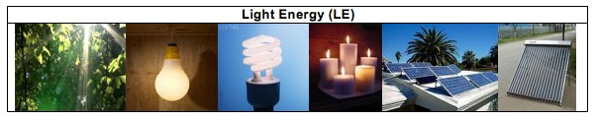
We use light every day. We use it to see things. Without light, our lives would be very difficult. Light helps our life more than just to help us see things. Sunlight helps plants grow. Doctors use special light to perform surgery. Light has light energy. When the lamp is turned on, it gives off light energy. When a candle is burning, the flame gives off light energy.

The light energy from the sun is sometimes called solar energy. The sun is a giant ball of burning gas. It gives off light all the time. It will keep shining and giving us energy for millions of years. Plants capture and use light energy to make their own food. Scientists have also invented ways to use light energy. Solar collectors on house roofs can capture light energy and use it to heat the water in the house. Solar cells on cars and house roofs can also capture light energy and use it to make electricity.

Can you think of other examples of light energy that you see every day?

Chemical energy is the energy stored in some special materials. Foods, fuels and body parts of all living things are made of materials that contain chemical energy.

All living things are made of cells. Cells are made of millions or even billions of molecules. The energy is stored in some molecules that make up cells. These molecules are carbohydrates and lipids (or fats). We call these molecules high-energy molecules. The molecules can be found in all living things.

Fossil fuels come from plants and animals living millions of years ago. The plant and animal debris was buried underground. Over long periods of time, the debris turned into fossil fuels. There are three types of fossil fuels – oil, natural gas, and coal. The major chemical component of fossil fuels is hydrocarbons. Like carbohydrates and lipids, hydrocarbons are also high-energy molecules. We use fossil fuels everyday. Our cars are powered by gasoline. We use methane for cooking. We use propane to barbecue and heat homes.

Can you think of more examples of things that have chemical energy?

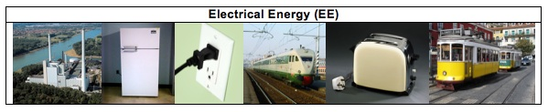

People use electricity everyday. Your family uses many electrical appliances at home. You watch TV after dinner. Your parents may use a laptop for work. You may use a toaster to toast bread or use a microwave oven to warm your food. To make these machines work, you should plug them into an outlet on the wall. What the machines get from the outlet is electricity. We not only use electricity to power our homes, school, or other buildings, but also use it for transportation. Electric trains or subway trains have engines that run on electricity. These engines get electricity through a metal rail under the train, or from wires at the top of the train. Electricity has electrical energy. Electricity is generated by different types of power plants. Wind power plants use wind to generate electricity. Nuclear power plants split uranium atoms to make electricity. Hydropower plants use the energy of moving water to make electricity. Fossil fuel fired power plants burn fossil fuels to generate electricity. In the United States, about 51% of our electricity comes from burning coal.

Do you know where your electricity comes from? What type of power plant do you depend on?

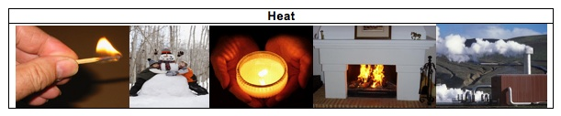
When you run a car for a while, the front of the car becomes very hot. When a flame from a candle or a campfire is burning, you can feel the warmth. When you are exercising, you also feel very hot. Even when you are playing outside on a cold winter day, your body stays warm. Your body temperature always stays close to 98.6°. In all these events, heat or heat energy is released.

Heat is a special form of energy. Whenever changes happen heat is always released (lost) to the outside of the system as a byproduct. Unlike light energy and chemical energy, heat cannot be “caught” by living organisms to help their body function or to help them move.

Other Forms of Energy
Gravitational energy is the energy stored due to a higher position or place. A rock resting at the top of a hill contains gravitational energy. When the rock loses its support, it will roll down the hill. In this case, the gravitation energy transforms into the motion energy. Hydropower, such as water in a reservoir behind a dam, is an example of gravitational energy. Hydropower plants use the gravitational energy of the water to make electricity.
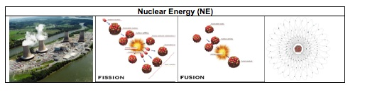
An atom is composed of electrons and a nucleus (neutrons and protons). Nuclear energy is the energy of the nucleus of an atom. There are two nuclear changes to release nuclear energy: fusion and fission. In fusion, nuclei are combined or “fused” together and nuclear energy is released in the form of heat and light energy. This is how the sun produces its heat and light energy. In fission, the nucleus of an atom splits apart and nuclear energy is also released in the form of heat and light energy. Nuclear power plants use the heat released from the fission of uranium atoms to generate electrical energy. Nuclear changes are different from chemical changes. Nuclear changes happen inside the atom, while the chemical changes only rearrange the atoms and do not change the atoms.

Activity 6: What happens when fuels burn?

Does Burning Release Energy: Modeling Combustion

Part 2. Why Can Fuels Burn? – Molecules of Fuels

In your groups, you will use molecular model kits to model the process of combustion of different fuel sources. You will model the following four fuels:

1. Burning Methane.
Methane, which takes up about 75% of natural gas, is used as energy source to heat your homes, cook food, or generate electricity.
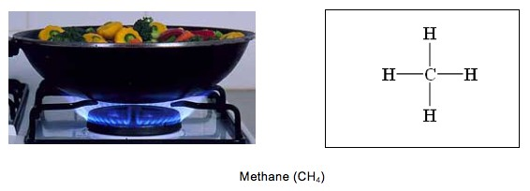

2. Burning butane.
In your classroom, you have butane burner for your chemistry labs. People often use butane lighter to light things, when they are having outdoor activities.
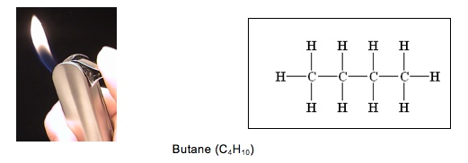

3. Burning propane.
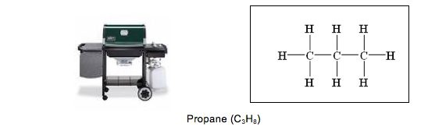
In the summertime, we often use gas grills to cook hamburgers and hot dogs. Many of the grills and camping stoves use propane fuel.

4. Burning ethanol.
In recent years there has been increasing publicity and support for using ethanol from corn as a fuel source for our automobiles. Currently ethanol is mixed with gasoline and burned by engines in our vehicles.
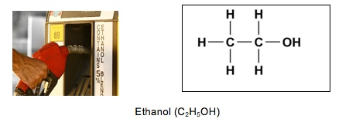

5. Burning gasoline
Gasoline is a mixture of hydrocarbons, including heptane (C₇H₁₆) and octane (C₈H₁₈).
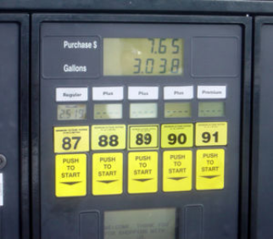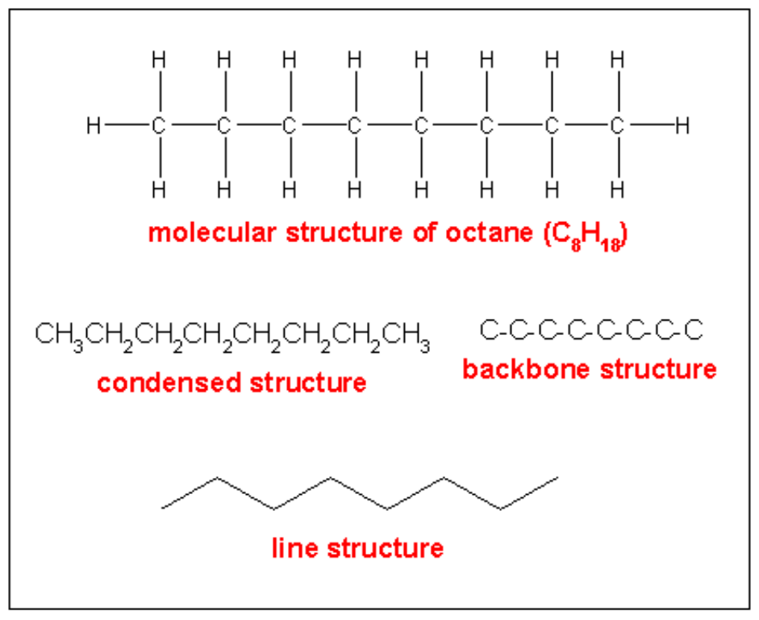
Octane (C₈H₁₈)
Activity 8: Identifying Energy-Rich Materials

Reading: Identifying energy-rich materials

Part 1: Chemical Energy in Plants, Animals, and Fuels
Where do plants and animals store energy in their bodies? Plants and animals are made of cells. The cells are made of millions and even billions of molecules, all used for a wide variety of purposes. The majority of a cell’s energy, however, is stored in several special types of molecules.

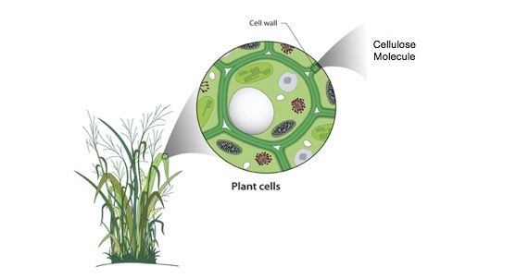
The picture below shows that leaves of corn plants are made of cells. These cells are able to capture light energy from the sun, and transform it into chemical energy through the process of photosynthesis. In this process, atoms found in carbon dioxide and water are used to make glucose molecules, which contain a lot of chemical energy. Eventually the glucose molecules become other types of molecules in plants, such as starch and cellulose. Cellulose molecules also contain a lot of chemical energy. Like glucose, cellulose is important to plants. Cellulose, however, is much less biologically accessible than glucose and starch for organisms to use as food, making it an excellent molecule for durability and structure, such as in plant cell wells, where it is the major chemical component (see picture below).
Plants also take in oxygen, because they need to be able to use the chemical energy in glucose and other molecules. Oxygen helps to release the chemical energy stored in these molecules. When these molecules react with oxygen, their chemical energy is used by the plant, and transformed into other forms of energy. At the same time, carbon dioxide and water are released out of the cell, and may eventually leave the plant.

People and other animals store energy in their bodies in a similar way, using molecules such as glucose, glycogen (very similar structure to plant starch) and lipids (fats). The muscle of the person’s arm is made of muscle cells. The muscle cells store millions of lipid molecules in specialized parts of the cell. Like cellulose molecules in plant cell walls, the lipid molecules also contain a lot of chemical energy. Unlike cellulose, though, lipids can be readily broken down by the cell and their stored energy released.

Just like plants, people need oxygen to release the chemical energy stored in the cells of their body. In the picture below, when the lipid molecule reacts with oxygen, its chemical energy is released for the person to use. At the same time, carbon dioxide and water are released out of the cell, and eventually leave the body.
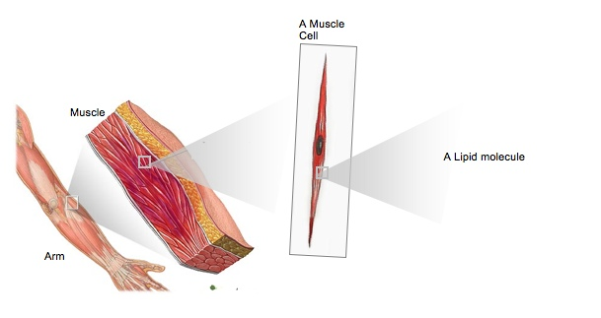

Part 2. Where Do Fossil Fuels Come From?

Picture 1 Picture 2 Picture 3
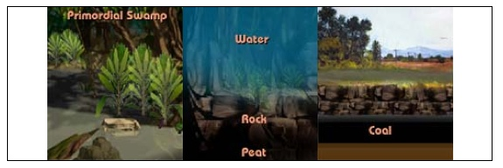

Fossil fuels were formed from plants and animals that lived approximately 300 million years ago in primordial swamps and oceans (Picture 1). Ancient plants and animals died and were buried under layers of sediment and eventually rock (Picture 2). The high temperature and pressure cause the debris (peat) to condense. Gradually the condensed organic matter was transformed into fossil fuels, like coal and oil, buried underneath layers of rock (Picture 3). These fuels retain much of the chemical energy present in the organisms when they were living.

The most commonly used fossil fuels are oil, coal, and natural gas. These substances are extracted from the earth’s crust and refined into suitable fuel products. Crude oil is refined into gasoline, diesel fuel, and jet fuel, which power the world’s transportation systems. Coal is the fuel most commonly burned to generate electric power for homes and buildings. Natural gas is used primarily in buildings for heating water and air, for air conditioning, and as fuel for stoves and other heating appliances.

In order to release the chemical energy found in fossil fuels, we must “burn” those fuels using oxygen. This process is called combustion. Combustion happens when oxygen reacts with fuels to release chemical energy. Note that this is essentially the same as the reactions discussed above in plant and animal cells; combustion is simply more tightly controlled in living cells, and called cell respiration. The chemical energy may change into many other forms of energy. In a coal power plant, the chemical energy of coal changes to electrical energy and heat. In a car engine, the chemical energy of gasoline changes to kinetic energy and heat. When other types of fuels, such as propane, are burned, their chemical energy changes to light energy and heat. When all these fuels burn, the matter that makes up the fuel changes to carbon dioxide and water. Since they are fossil fuels, however, the matter and energy being released during combustion is ancient, and was last present in the earth’s atmosphere millions of years ago. Wide-scale use of fossil fuels in recent centuries has dramatically increased the concentration of gases like carbon dioxide in the atmosphere, and is the principal cause of the greenhouse effect and global warming.
Part 3: C-C and C-H Bonds and Chemical Energy
Look at some of the common molecules that make up plants, animals, and fossil fuels.
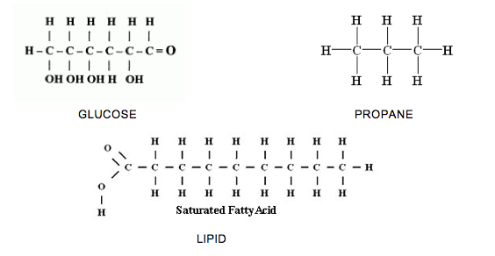
What do you notice about the atoms that are found in these materials?

What atoms are bonded to each other?

In general molecules that have C-C and C-H bonds have lots of energy. That means when you see a molecule where carbon is bonded to another carbon, or where carbon is bonded to hydrogen, that molecule has lots of chemical energy. Some molecules are not rich with chemical energy. These molecules contain O-H and O-C bonds. Materials that only include oxygen bonded to hydrogen or oxygen bonded to carbon are not chemical energy sources.

Octane ratings concern the ability of different mixtures in gasoline to resist detonation or knock. Using a higher-level octane will not improve the gas mileage, since the total C-H and C-C bonds contained in the mixture will not change.

